**Assignment 3**

**Question 1**

Created a IAM user and assigning a Administrator policy   
  
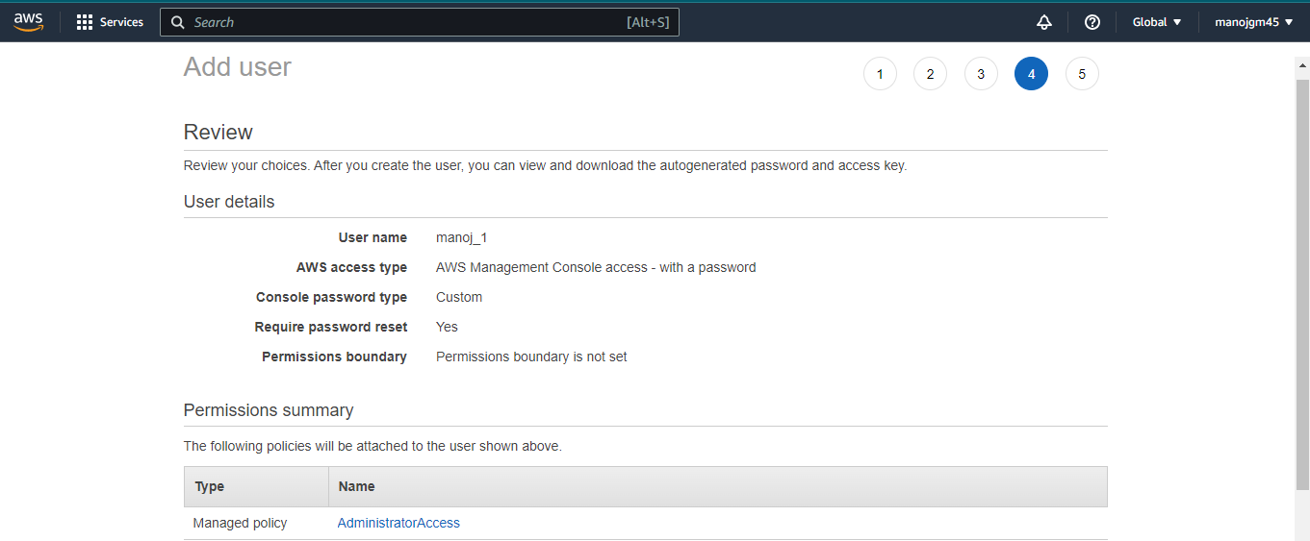

**Question 2**  
Created Developer Group which contains 3 users with administrator acess

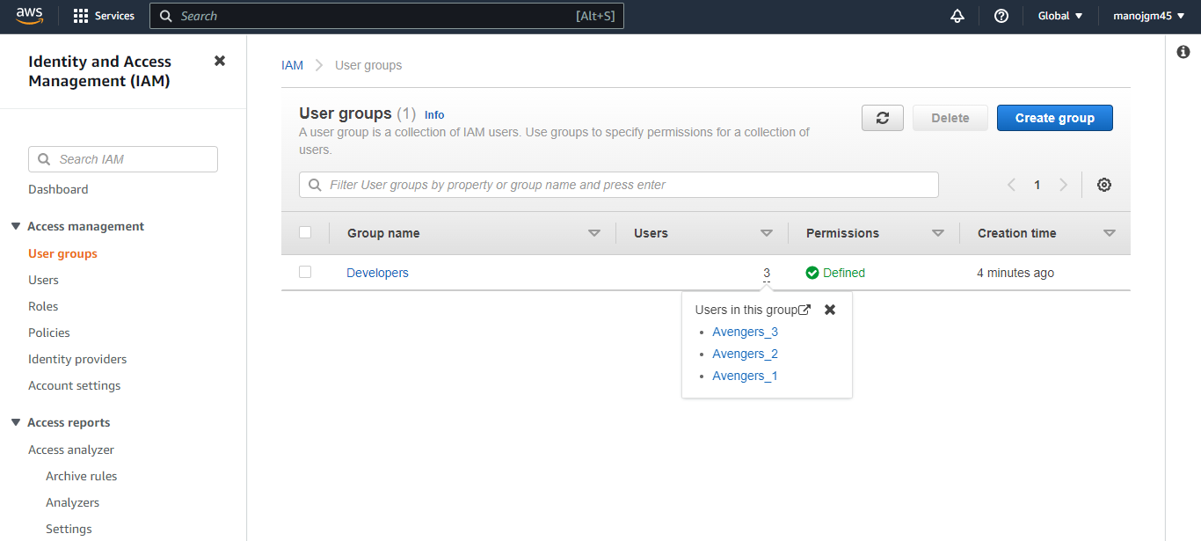

**Question 3**  
  
I have created a Policy where it contains administrator full access with a condition of certain Time frame and its JSON goes as follows

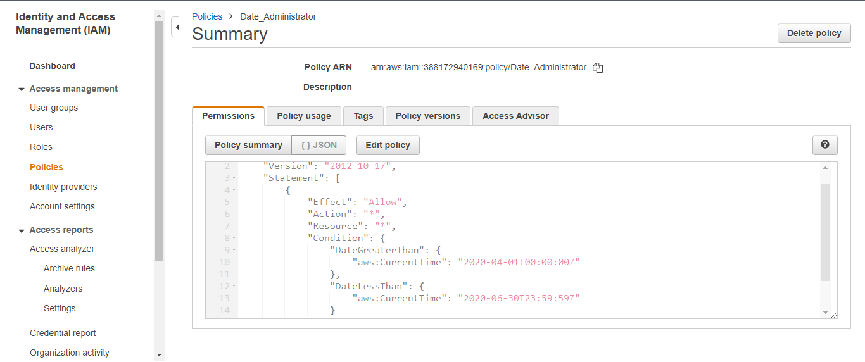

**Question 4**

1. AWS evaluates _______ when an IAM principal makes a request.

(a) Username and Password

(b) MAC Address

(c) Security Policies

(d) IP Address

ANSWER – c

|  |
| --- |
|  |

1. IAM role:

(a) Have credentials (password or access keys) associated with it

(b) Does not have any credentials (password or access keys) associated with it

(c) May or may not have credentials (password or access keys) associated with it

(d) None of these

ANSWER – b

1. Which of these is IAM principal?

(a) A user

(b) A role

(c) An application

(d) All of these

ANSWER – d

1. An IAM user:

(a) is an entity that you create in AWS

(b) is to give people the ability to sign in to the AWS Management Console for interactive tasks and to make programmatic requests to AWS services using the API or CLI

(c) A and B both

(d) None of these

ANSWER – c

1. Which of these is Identity in IAM?

(a) Users

(b) Groups

(c) Roles

(d) All of these

ANSWER – d

1. How many maximum managed policies can be assigned to an IAM entity?

(a) 2

(b) 5

(c) 10

(d) 20

ANSWER – c

1. Which of these is not an IAM policy type?

(a) Smart policies

(b) Access control lists (ACLs)

(c) Session policies

(d) Organizations SCPs

ANSWER – d

1. How many maximum groups can be created in an AWS account?

(a) 25

(b) 50

(c) 100

(d) 200

ANSWER – c

1. How many maximum users can be created in an AWS account?

(a) 2000

(b) 5000

(c) 8000

(d) 10000

ANSWER – b

1. How many maximum roles can be created in an AWS account?

(a) 200

(b) 300

(c) 400

(d) 500

ANSWER – d

**Question 5**  
First we need to launch an ubuntu instance in AWS.  
Run the commands apt-get upgrade and  
Run the command apt-get dist-upgrade

